**Project Planning Phase**

**Project Planning Template(Product Backlog, Sprint Planning, Stories, Story points)**

|  |  |
| --- | --- |
| Date | 18 October 2022 |
| Team ID | PNT2022TMID22283 |
| Project Name | Project - Early Detection of Chronic kidney Disease using Machine Learning |
| Maximum Marks | 8 Marks |

**Product Backlog, Sprint Schedule, and Estimation (4 Marks)**

Use the below template to create product backlog and sprint schedule

| **Sprint** | **Functional Requirement (Epic)** | **User Story Number** | **User Story / Task** | **Story Points** | **Priority** | **Team Members** |
| --- | --- | --- | --- | --- | --- | --- |
| Sprint-1 | Registration | USN-1 | As a user, I can register for the application by entering my email, password, and confirming my password. | 10 | High | Avinash |
|  | Login | USN-2 | As a user, I can log into the application by entering email & password | 10 | High | Gokul |
|  |  |  |  |  |  |  |
| Sprint-2 | Data Cleaning | USN-3 | Handling the missing values | 4 | High | Edwin Kingsten |
|  |  | USN-4 | Handling Outliers | 3 | High | Edwin Kingsten |
|  |  | USN-5 | Label Encoding | 3 | High | Edwin Kingsten |
|  | ML Model Building | USN-6 | Splitting dataset into train set and test set | 2 | High | Edwin Kingsten |
|  |  | USN-7 | Choosing Appropriate Model | 3 | High | Edwin Kingsten |
|  |  | USN-8 | Fitting and Evaluating the Model | 5 | High | Edwin Kingsten |
|  |  |  |  |  |  |  |
| Sprint-3 | Entry Form | USN-9 | As a user ,I can enter the data to get the result | 10 | High | Gokul |
|  | Train Model on IBM | USN-10 | Register for IBM cloud | 2 | High | Manikandan |
|  |  | USN-11 | Creating Watson Studio Project | 2 | High | Manikandan |
|  |  | USN-12 | Creating Cloud Object Storage | 2 | High | Manikandan |
|  |  | USN-13 | Deploy Model on Watson Machine Learning | 4 | High | Manikandan |
|  |  |  |  |  |  |  |
| Sprint-4 | Flask Integration | USN-14 | Routing and rendering html files | 3 | High | Avinash |
|  |  | USN-15 | Connection with database | 3 | High | Avinash |
|  |  | USN-16 | Requesting ML token from IBM | 5 | High | Manikandan |
|  |  | USN-17 | Sending request to the deployed Model | 5 | High | Manikandan |
|  | Result | USN-18 | As a user ,I can get the results and navigate back to entry form | 4 | High | Avinash |

**Project Tracker, Velocity & Burndown Chart: (4 Marks)**

| **Sprint** | **Total Story Points** | **Duration** | **Sprint Start Date** | **Sprint End Date (Planned)** | **Story Points Completed (as on Planned End Date)** | **Sprint Release Date (Actual)** |
| --- | --- | --- | --- | --- | --- | --- |
| Sprint-1 | 20 | 6 Days | 24 Oct 2022 | 29 Oct 2022 | 20 | 29 Oct 2022 |
| Sprint-2 | 20 | 6 Days | 31 Oct 2022 | 05 Nov 2022 | 20 | 05 Oct 2022 |
| Sprint-3 | 20 | 6 Days | 07 Nov 2022 | 12 Nov 2022 | 20 | 12 Nov 2022 |
| Sprint-4 | 20 | 6 Days | 14 Nov 2022 | 19 Nov 2022 | 20 | 15 Nov 2022 |

**Velocity:**

Imagine we have a 10-day sprint duration, and the velocity of the team is 20 (points per sprint). Let’s calculate the team’s average velocity (AV) per iteration unit (story points per day)

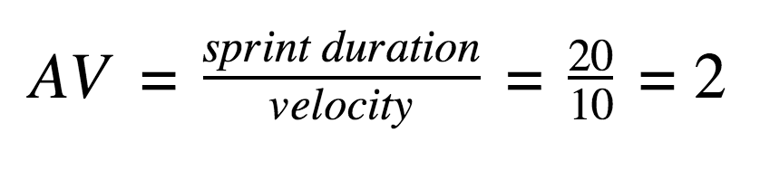

**Burndown Chart:**

A burn down chart is a graphical representation of work left to do versus time. It is often used in agile[software development](https://www.visual-paradigm.com/scrum/what-is-agile-software-development/) methodologies such as [Scrum](https://www.visual-paradigm.com/scrum/scrum-in-3-minutes/). However, burn down charts can be applied to any project containing measurable progress over time.